**A southern Indian Middle Palaeolithic occupation surface sealed by the 74 ka Toba eruption: Further evidence from Jwalapuram Locality 22**

Michael Haslam, Chris Clarkson, Richard G. Roberts, Janardhana Bora, Ravi Korisettar, Peter Ditchfield, Allan Chivas, Clair Harris, Victoria Smith, Anna Oh, Sanjay Eksambekar, Nicole Boivin and Michael Petraglia

*Supplementary Online Material*

**Methods**

Tephra geochemistry analysis, sediment particle size analysis, magnetic susceptibility analysis, isotopic analysis of carbonate nodules, and X-ray fluorescence were conducted at the Research Laboratory for Archaeology and the History of Art, School of Archaeology, University of Oxford. Optically stimulated luminescence, X-ray fluorescence and 13C analysis of the sediment organic fraction were conducted at the Geochemistry Laboratory in the School of Earth and Environmental Sciences, University of Wollongong. Phytolith analysis was conducted at the Phytolith Research Institute, Pune, India.

*Optically stimulated luminescence*

Samples were prepared for dating using standard procedures (Aitken, 1998) to extract quartz grains of 180–212 µm in diameter. Single-grain OSL measurements were made using the same equipment and single-aliquot regenerative-dose (SAR) procedures as employed previously at Jwalapuram (2009a; 2009b; Petraglia et al., 2007), and aberrant grains were rejected using the criteria described and tested in these studies and by Jacobs et al. (2006; 2008). The SAR procedure involves measuring the OSL signals from the natural (burial) dose and from a series of regenerative doses (given in the laboratory by means of a calibrated beta source), each of which were preheated at 260ºC for 10 s prior to optical stimulation by a green laser beam for 2 s at 125°C. A small test dose (preheated at 160ºC for 10 s) was given after each natural and regenerative dose, and the resulting OSL signals were used to correct for any sensitivity changes. The De values were estimated from the first 0.2 s of OSL decay, with the mean count recorded over the last 0.3 s being subtracted as background. An instrumental reproducibility uncertainty of 2% was added in quadrature to the photon counting statistics for each OSL measurement (Jacobs et al., 2006), and an additional 2% was included in the final De uncertainty to allow for any bias in the beta source calibration. These experimental conditions and methods of data analysis were chosen on the basis of tests performed on OSL samples from nearby Localities 3 and 21 (2009a; 2009b; Petraglia et al., 2007) that had been bleached and then given a known dose before any OSL measurements. The ratios of measured/given dose of 0.996 ± 0.034 and 0.985 ± 0.015, respectively, indicate that the SAR procedures employed here can reliably recover a known dose for quartz grains from Jwalapuram.

The environmental dose rate consists of beta, gamma and cosmic radiation contributions, as well as a small internal alpha dose rate. For the latter, an assumed value of 0.03 ± 0.01 Gy/ka was included in the total dose rate. The beta and gamma dose rates were measured directly by beta counting of dried, homogenised and powdered samples in the laboratory and by in situ gamma spectrometry at each sample location, with the Na(Tl) detector inserted into the hole left after removing the metal tube. Details of equipment and analytical methods follow those described by Jacobs et al. (2008). Use of these techniques to accurately determine the present-day dose rate will minimise the effects of any changes in dose rate during the period of sample burial arising from time-dependent disequilibria in the 238U and 232Th decay chains; the maximum error is apt to be no more than a few percent (Olley et al., 1996; Olley et al., 1997), which is smaller than the uncertainty on the De. A correction was made for attenuation of the beta dose with grain size and the cosmic-ray dose rate was adjusted for the geomagnetic latitude and altitude of Locality 22, as well as the thickness and density of sedimentary overburden. The beta, gamma and cosmic-ray dose rates were calculated for a water content of 14 ± 3% (using the correction factors of Nathan and Mauz, 2008), which is slightly moister than the measured (field) water contents (11–12%) to allow for sample collection during the dry season, as well as drying out of the section face after excavation. The OSL ages are not especially sensitive to the value used, increasing by ~1% for each 1% increase in water content, and the uncertainty on this estimate should accommodate the likely variations in moisture integrated over the period of sample burial.

*Tephra geochemistry*

Major element composition of the tephra glass shards from sample SS18 (200 cm depth) was determined using a Jeol 8600 wavelength-dispersive electron microprobe equipped with 4 spectrometers. To reduce the impact of alkali-loss on the analysis a 15 kV accelerating voltage and a 6 nA, 10 µm beam were used. Na was collected for 10 s, while most other elements were collected for 30 s apart from Cl and P that were collected for 60 s. A suite of mineral standards were used to calibrate the instrument, and a suite of MPI-DING glasses were used as secondary standards. During all runs, the secondary standards were within 2 standard deviations of the preferred values. Due to variable secondary hydration of glasses all the analyses are normalised to 100%.

*Particle size analysis*

To prepare for particle size analysis, sediment samples were first dispersed in weak hydrochloric acid (0.5 M) to remove carbonates, then in sodium hexametaphosphate solution (6.2 g of (NaPO3)6 to 1 L of distilled water) to separate fine particles. The samples were then dried in an oven at 50°C for 36 hours. A Mastersizer 2000 laser granulometer (Malvern Instruments) was used to measure the grain sizes. Dry samples were dispersed in distilled water in the dispersion unit, and passed through a cell with a glass window where a laser beam measured the grain sizes. A computer linked to the Mastersizer 2000 collected the data, with data collection repeated five times per sample to check for anomalies in the measurements. Dry sediment colour was recorded using a Munsell colour chart.

*Magnetic susceptibility*

Magnetic susceptibility was measured at room temperature using a Bartingon Instruments MS2 meter, with a dual-frequency MS2B sensor (Dearing et al., 1996). Sediment samples were first homogenised using a mortar and pestle and then dried overnight in an oven at 30°C. Each 10 ml sample was placed in a small measuring glass, with sample weights recorded to the nearest hundredth of a gram for later standardisation of measurements. Volume susceptibility (κ; representing the ratio of the magnetisation to field [80 A m-1] in the SI scheme) was measured for each sample using both low (κlf; 0.46 kHz) and high (κhf; 4.6 kHz) frequencies (Dearing, 1999; Dearing et al., 1996). Each reading was then divided by the sample bulk density (ρ) in kg m-3 to convert κ to mass-specific susceptibility (χ) data. As described by Dearing (1999), the two frequency measurements are used to detect the presence of ultrafine (<0.03 µm) superparamagnetic (SP) ferrimagnetic minerals occurring as crystals in soils. Samples with ultrafine minerals show slightly lower susceptibility values when measured at high frequency. Frequency dependent susceptibility (χfd%) was calculated as a percentage of the low frequency κ value using the equation: χfd% = (κlf-κhf/κlf) x 100, and mass-specific frequency dependent susceptibility (χfd) using: χfd= (κlf-κhf)/ρ.

*Carbonate istopes*

Carbonate nodules analysed at the University of Oxford were rinsed in deionised water to remove adhering sediment. Only micritic (fine-grained) pedogenic carbonate nodules were selected for analysis, and those with visible sparry (macro-crystalline) carbonate cements were rejected, as they were likely to have been diagenetically altered. Three nodules were selected from each of the collected sediment samples to record the range of semi-synchronic isotopic variability. Nodules were dried in a 60ºC oven, then crushed in an agate pestle and mortar. Oxygen and carbon stable isotopic results were obtained using a VG Isogas Prism II mass spectrometer with an on-line VG Isocarb common acid bath preparation system. Each sample was reacted with purified phosphoric acid (H3PO4) at 90ºC, with the liberated carbon dioxide cryogenically distilled prior to admission to the mass spectrometer. Both oxygen and carbon isotopic ratios are reported relative to the VPDB international standard. Calibration was against the in-house NOCZ Carrara Marble standard with a reproducibility of better than 0.2 per mil, corrected following the procedure of Craig (1957). Only samples from below the Toba tephra at Locality 22 (from depths of 210-330 cm below the site surface) were analysed for carbonate isotopes in this study.

Carbon isotope (13C) data from the organic carbon fraction was obtained at the University of Wollongong. Sediment samples were first decarbonised using HCl to eliminate all carbonates, then washed using milli-Q water in an ultrasonic bath three times, with the water subsequently separated from the sediments using a centrifuge. The samples were then dried in an oven at 60°C over night, and weighed to assess the carbon content in relation to sample size. The 13C data was obtained using a PRISM III mass spectrometer with continuous flow and He carrier gas.

*X-ray fluorescence*

X-ray fluorescence at the University of Oxford was conducted on homogenised 5 g sediment samples using a portable Bruker Tracer III-V handheld XRF system with SiPIN detector and attached vacuum pump. Major elements were recorded using settings of 15 kV and 15 µA, with 180 s run time and 1 mil Ti filter. Trace elements were recorded using settings of 40 kV and 13 µA, with 12 mil Al/1 mil Ti/6 mil Cu filter and 180 s run time. Output spectra were analysed using ARTAX software. X-ray fluorescence of trace elements at the University of Wollongong involved first weighing out approximately 5 g of powdered sediment, then adding five to six drops of an organic binder solution (PVC) to consolidate the sample. Each sample was pressed into pellets using aluminium cups before drying in an oven for 12 hours at ~60°C. The samples were analysed using a Spectro Xepos XRF machine.

*Phytolith analysis*

Phytolith extraction and analysis for Locality 22 samples followed published protocols (Pearsall, 1989), with modifications dependent on the sediment type. The modifications were necessary as most of the samples had uneven concentrations of organic matter and a high fraction of clay. Samples were first deflocculated, then filtered through a 210 µm sieve. HCl was used to remove carbonates, and nitrates were removed by HNO3 followed by centrifugation, washing and decanting. This process was followed by heavy density separation using a solution of CdI2 and KI (specific gravity 2.4). Extracted phytoliths were mounted on glass slides and observed under transmitted illumination using an optical microscope.

**References**

Aitken, M.J., 1998. An Introduction to Optical Dating. Oxford University Press, Oxford.

Chesner, C.A., 1998. Petrogenesis of the Toba Tuffs, Sumatra, Indonesia. J. Petrol. 39, 397-438.

Craig, H., 1957. Isotopic standards for carbon and oxygen and correction factors for mass-spectrometric analysis of carbon dioxide. Geochim. Cosmochim. Acta 12, 133-149.

Dearing, J., 1999. Environmental Magnetic Susceptibility. Using the Bartington MS2 System, 2nd ed. Bartington Instruments Ltd, Oxford.

Dearing, J., Dann, R.J.L., Hay, K., Lees, J.A., Loveland, P.J., Maher, B.A., O'Grady, K., 1996. Frequency-dependent susceptibility measurements of environmental materials. Geophys. J. Int. 124, 228-240.

Haslam, M., Clarkson, C., Petraglia, M., Korisettar, R., Jones, S., Shipton, C., Ditchfield, P., Ambrose, S.H., 2010. The 74,000 BP Toba super-eruption and southern Indian hominins: archaeology, lithic technology and environments at Jwalapuram Locality 3. J. Archaeol. Sci. 37, 3370-3384.

Jacobs, Z., Duller, G.A.T., Wintle, A.G., 2006. Interpretation of single grain De distributions and calculation of De. Radiat. Meas. 41, 264-277.

Jacobs, Z., Roberts, R.G., Galbraith, R., Deacon, H.J., Grun, R., Mackay, A., Mitchell, P., Vogelsang, R., Wadley, L., 2008. Ages for the Middle Stone Age of southern Africa: implications for human behavior and dispersal. Science 322, 733-735.

Nathan, R., Mauz, B., 2008. On the dose-rate estimate of carbonate-rich sediments for trapped charge dating. Radiat. Meas. 43, 14-25.

Olley, J., Murray, A., Roberts, R.G., 1996. The effects of disequilibria in the uranium and thorium decay chains on burial dose rates in fluvial sediments. Quat. Sci. Rev. 15, 751-760.

Olley, J., Roberts, R.G., Murray, A., 1997. Disequilibria in the uranium decay series in sedimentary deposits at Allen’s Cave, Nullarbor Plain, Australia: implications for dose rate determinations. Radiat. Meas. 27.

Pearsall, D.M., 1989. Paleoethnobotany: a handbook of procedures, 1st ed. Academic Press, New York.

Petraglia, M., Clarkson, C., Boivin, N., Haslam, M., Korisettar, R., Chaubey, G., Ditchfield, P., Fuller, D., James, H., Jones, S., Kivisild, T., Koshy, J., Lahr, M.M., Metspalu, M., Roberts, R., Arnold, L., 2009a. Population increase and environmental deterioration correspond with microlithic innovations in South Asia ca. 35,000 years ago. Proc. Natl. Acad. Sci. U.S.A. 106, 12261-12266.

Petraglia, M., Korisettar, R., Bai, M.K., Boivin, N., Janardhana B., Clarkson, C., Cunningham, K., Ditchfield, P., Fuller, D., Hampson, J., Haslam, M., Jones, S., Koshy, J., Miracle, P., Oppenheimer, C., Roberts, R., White, K., 2009b. Human occupation, adaptation and behavioral change in the Pleistocene and Holocene of south India: recent investigations in the Kurnool district, Andhra Pradesh. Eurasian Prehist. 6, 119-166.

Petraglia, M., Korisettar, R., Boivin, N., Clarkson, C., Ditchfield, P., Jones, S., Koshy, J., Lahr, M.M., Oppenheimer, C., Pyle, D., Roberts, R., Schwenninger, J.-L., Arnold, L., White, K., 2007. Middle Palaeolithic assemblages from the Indian subcontinent before and after the Toba super-eruption. Science 317, 114-116.

Westgate, J., Shane, P., Pearce, N., Perkins, W., Korisettar, R., Chesner, C.A., Williams, M., Acharyya, S.K., 1998. All Toba tephra occurrences across Peninsular India belong to the 75,000 yr B.P. eruption. Quat. Res. 50, 107-112.

Table S1. Results of the particle size analysis, Jwalapuram Locality 22

|  |  |  |  |  |  |  |  |  |  |  |  |  |  |  |  |  |  |
| --- | --- | --- | --- | --- | --- | --- | --- | --- | --- | --- | --- | --- | --- | --- | --- | --- | --- |
| Sample code | Depth1 (cm) | Munsell colour (dry) | Mean2 (µm) | Sorting | Skewness | Kurtosis | %3 | | | | | | | | | | |
| VCSa | CSa | MSa | FSa | VFSa | VCSi | CSi | MSi | FSi | VFSi | Clay |
| SS1 | 30 | 7.5YR 6/8 | 43.69 | 61.73 | 3.20 | 17.03 | 0.0 | 0.1 | 1.8 | 5.9 | 12.9 | 19.0 | 18.8 | 15.2 | 10.6 | 6.6 | 9.1 |
| SS2 | 40 | 7.5YR 6/6 | 66.69 | 88.74 | 2.82 | 13.34 | 0.0 | 0.6 | 4.2 | 9.9 | 18.2 | 20.9 | 16.2 | 11.3 | 7.3 | 4.6 | 6.8 |
| SS3 | 50 | 7.5YR 6/6 | 110.49 | 160.61 | 2.09 | 7.17 | 0.0 | 4.4 | 10.7 | 10.9 | 13.3 | 14.9 | 13.1 | 10.7 | 8.2 | 5.8 | 8.0 |
| SS4 | 60 | 7.5YR 6/6 | 248.23 | 314.73 | 1.91 | 6.96 | 3.8 | 12.9 | 17.1 | 14.2 | 12.9 | 10.8 | 8.0 | 6.4 | 5.2 | 3.8 | 4.9 |
| SS5 | 70 | 7.5YR 6/6 | 127.45 | 153.73 | 1.53 | 4.80 | 0.0 | 3.8 | 14.9 | 15.2 | 14.8 | 13.6 | 10.6 | 8.4 | 6.7 | 5.0 | 7.0 |
| SS6 | 80 | 7.5YR 6/6 | 119.17 | 139.57 | 1.40 | 4.16 | 0.0 | 2.4 | 14.8 | 16.1 | 14.9 | 13.3 | 10.4 | 8.7 | 7.0 | 5.2 | 7.1 |
| SS7 | 90 | 7.5YR 6/6 | 132.91 | 170.44 | 1.50 | 4.53 | 0.0 | 5.3 | 15.8 | 12.5 | 11.8 | 11.7 | 10.9 | 10.5 | 8.4 | 5.8 | 7.4 |
| SS8 | 100 | 7.5YR 6/6 | 111.19 | 157.84 | 1.81 | 5.78 | 0.0 | 4.1 | 12.7 | 11.1 | 10.9 | 11.8 | 12.3 | 12.3 | 10.1 | 6.8 | 8.0 |
| SS9 | 110 | 7.5YR 6/6 | 39.21 | 53.42 | 2.44 | 9.42 | 0.0 | 0.0 | 1.3 | 6.5 | 10.5 | 17.2 | 18.7 | 17.0 | 12.9 | 7.8 | 8.2 |
| SS10 | 120 | 7.5YR 6/6 | 51.39 | 59.24 | 1.79 | 6.24 | 0.0 | 0.0 | 1.5 | 9.9 | 16.8 | 20.1 | 16.4 | 11.6 | 8.7 | 6.5 | 8.5 |
| SS11 | 130 | 7.5YR 6/6 | 107.13 | 134.59 | 1.61 | 4.89 | 0.0 | 2.2 | 12.5 | 14.5 | 14.4 | 13.8 | 11.7 | 9.9 | 8.0 | 5.8 | 7.2 |
| SS12 | 140 | 7.5YR 6/6 | 100.90 | 136.90 | 1.75 | 5.23 | 0.0 | 2.5 | 11.9 | 11.1 | 13.1 | 14.8 | 13.8 | 11.5 | 8.2 | 5.6 | 7.3 |
| SS13 | 150 | 7.5YR 6/6 | 107.68 | 131.66 | 1.57 | 4.78 | 0.0 | 1.9 | 13.0 | 14.2 | 15.1 | 15.4 | 12.5 | 9.6 | 7.0 | 4.7 | 6.4 |
| SS14 | 160 | 7.5YR 6/6 | 46.06 | 54.91 | 1.85 | 6.51 | 0.0 | 0.0 | 1.0 | 8.6 | 15.6 | 18.7 | 16.1 | 13.1 | 10.4 | 7.2 | 9.2 |
| SS15 | 170 | 7.5YR 6/6 | 62.90 | 72.53 | 1.51 | 4.67 | 0.0 | 0.0 | 3.3 | 14.3 | 16.0 | 17.0 | 15.1 | 12.2 | 9.0 | 5.8 | 7.3 |
| SS16 | 180 | 7.5YR 6/6 | 57.86 | 78.06 | 1.98 | 6.79 | 0.0 | 0.0 | 4.1 | 11.3 | 13.4 | 14.8 | 14.2 | 13.1 | 11.1 | 7.9 | 10.1 |
| SS17 | 190 | 7.5YR 7/6 | 38.93 | 43.42 | 2.19 | 8.93 | 0.0 | 0.0 | 0.4 | 5.0 | 13.3 | 23.1 | 22.2 | 13.9 | 8.5 | 5.8 | 7.8 |
| SS18 | 200 | 7.5YR 7/6 | 61.19 | 69.80 | 1.98 | 7.14 | 0.0 | 0.0 | 3.3 | 10.9 | 17.1 | 23.3 | 18.9 | 10.7 | 6.4 | 4.1 | 5.4 |
| SS19 | 210 | 10YR 5/4 | 117.55 | 120.10 | 1.60 | 5.29 | 0.0 | 1.6 | 11.9 | 18.8 | 22.9 | 20.1 | 11.6 | 5.7 | 3.1 | 1.9 | 2.4 |
| SS20 | 220 | 10YR 6/4 | 125.48 | 118.49 | 1.49 | 4.97 | 0.0 | 1.5 | 12.8 | 21.7 | 24.7 | 19.1 | 10.0 | 4.6 | 2.4 | 1.4 | 1.8 |
| SS21 | 230 | 10YR 6/4 | 89.40 | 95.56 | 1.82 | 6.55 | 0.0 | 0.4 | 7.5 | 15.8 | 22.1 | 21.2 | 14.7 | 8.5 | 4.4 | 2.4 | 3.1 |
| SS22 | 240 | 10YR 5/4 | 144.67 | 139.46 | 1.44 | 5.00 | 0.0 | 3.0 | 15.9 | 22.8 | 21.5 | 15.8 | 9.6 | 5.1 | 2.7 | 1.6 | 1.9 |
| SS23 | 250 | 10YR 6/4 | 117.50 | 116.92 | 1.46 | 4.83 | 0.0 | 1.1 | 12.5 | 20.1 | 22.1 | 18.4 | 11.5 | 6.2 | 3.4 | 2.1 | 2.6 |
| SS24 | 260 | 10YR 6/4 | 122.85 | 110.63 | 1.33 | 4.57 | 0.0 | 0.8 | 12.6 | 23.8 | 23.9 | 17.7 | 10.5 | 5.0 | 2.4 | 1.5 | 1.8 |
| SS25 | 270 | 7.5YR 5/4 | 117.40 | 108.49 | 1.36 | 4.69 | 0.0 | 0.7 | 11.8 | 22.7 | 23.9 | 17.8 | 10.6 | 5.6 | 2.9 | 1.8 | 2.3 |
| SS26 | 280 | 7.5YR 5/4 | 129.69 | 136.51 | 1.73 | 6.39 | 0.0 | 2.7 | 13.1 | 20.8 | 20.9 | 16.3 | 11.1 | 6.8 | 3.7 | 2.0 | 2.5 |
| SS27 | 290 | 7.5YR 5/4 | 102.13 | 106.15 | 1.56 | 5.30 | 0.0 | 0.6 | 9.9 | 18.7 | 21.2 | 18.0 | 13.0 | 8.2 | 4.4 | 2.6 | 3.4 |
| SS28 | 300 | 7.5YR 5/4 | 141.25 | 129.02 | 1.27 | 4.14 | 0.0 | 2.2 | 15.8 | 24.1 | 22.5 | 15.5 | 8.9 | 4.9 | 2.6 | 1.5 | 1.9 |
| SS29 | 310 | 7.5YR 5/6 | 111.60 | 111.29 | 1.60 | 5.57 | 0.0 | 1.1 | 10.5 | 20.3 | 23.7 | 18.4 | 10.8 | 6.4 | 3.8 | 2.2 | 2.8 |
| SS30 | 320 | 7.5YR 4/6 | 105.65 | 104.46 | 1.58 | 5.53 | 0.0 | 0.6 | 9.7 | 19.7 | 23.5 | 19.6 | 12.3 | 6.5 | 3.4 | 2.0 | 2.7 |
| SS31 | 330 | 7.5YR 5/6 | 113.37 | 108.82 | 1.52 | 5.32 | 0.0 | 0.9 | 10.7 | 21.5 | 24.3 | 18.0 | 10.4 | 5.9 | 3.4 | 2.1 | 2.7 |

1. Depth below modern site surface
2. Mean, sorting, skewness and kurtosis calculated as arithmetic values
3. V = very; C = coarse; M = medium; F = fine; Sa = sand; Si = silt

Table S2. Magnetic susceptibility results, Jwalapuram Locality 22

|  |  |  |  |  |  |
| --- | --- | --- | --- | --- | --- |
| Sample | Depth (cm) | χlf1 | χhf2 | χfd%3 | χfd4 |
| SS1 | 30 | 1.7129 | 1.5590 | 8.98 | 153.9 |
| SS2 | 40 | 1.8777 | 1.6864 | 10.19 | 191.3 |
| SS3 | 50 | 2.0472 | 1.8417 | 10.04 | 205.5 |
| SS4 | 60 | 2.2143 | 1.9761 | 10.76 | 238.2 |
| SS5 | 70 | 2.2806 | 2.0092 | 11.90 | 271.3 |
| SS6 | 80 | 2.0868 | 1.8658 | 10.59 | 220.9 |
| SS7 | 90 | 1.8325 | 1.6245 | 11.35 | 208.0 |
| SS8 | 100 | 1.9640 | 1.7262 | 12.11 | 237.8 |
| SS9 | 110 | 2.2842 | 2.0530 | 10.12 | 231.2 |
| SS10 | 120 | 2.3759 | 2.1167 | 10.91 | 259.2 |
| SS11 | 130 | 2.1088 | 1.8853 | 10.60 | 223.5 |
| SS12 | 140 | 1.8103 | 1.5958 | 11.85 | 214.5 |
| SS13 | 150 | 1.7739 | 1.5705 | 11.47 | 203.4 |
| SS14 | 160 | 2.2679 | 2.0513 | 9.55 | 216.6 |
| SS15 | 170 | 2.2093 | 1.9275 | 12.75 | 281.8 |
| SS16 | 180 | 1.7688 | 1.5623 | 11.68 | 206.6 |
| SS17 | 190 | 0.9828 | 0.8773 | 10.73 | 105.4 |
| SS18 | 200 | 0.8112 | 0.7297 | 10.05 | 81.5 |
| SS19 | 210 | 0.4793 | 0.4285 | 10.61 | 50.8 |
| SS20 | 220 | 0.5442 | 0.4869 | 10.52 | 57.3 |
| SS21 | 230 | 0.5896 | 0.5423 | 8.02 | 47.3 |
| SS22 | 240 | 1.0022 | 0.9030 | 9.90 | 99.2 |
| SS23 | 250 | 1.1887 | 1.0345 | 12.97 | 154.2 |
| SS24 | 260 | 1.3168 | 1.1596 | 11.94 | 157.2 |
| SS25 | 270 | 1.6571 | 1.4945 | 9.81 | 162.6 |
| SS26 | 280 | 1.8994 | 1.7355 | 8.63 | 163.9 |
| SS27 | 290 | 1.9971 | 1.7804 | 10.85 | 216.7 |
| SS28 | 300 | 2.1286 | 1.9118 | 10.19 | 216.8 |
| SS29 | 310 | 2.0559 | 1.8996 | 7.61 | 156.4 |
| SS30 | 320 | 2.0384 | 1.7388 | 14.70 | 299.6 |
| SS31 | 330 | 2.1244 | 1.9324 | 9.04 | 192.0 |

1. χlf = mass specific susceptibility, low frequency (10-6 m3 kg-1)
2. χhf = mass specific susceptibility, high frequency (10-6 m3 kg-1)
3. χfd% = percentage frequency dependent susceptibility
4. χfd = mass specific frequency dependent susceptibility (10-9 m3 kg-1)

Table S3. Selected XRF sediment trace and major element results, Jwalapuram Locality 22

|  |  |  |  |  |  |  |  |  |  |  |  |
| --- | --- | --- | --- | --- | --- | --- | --- | --- | --- | --- | --- |
| Univ. of Wollongong (results in parts per million)1 | | | | | | | | | Univ. of Oxford1,2 | | |
| Depth (cm) | Cu | As | Rb | Sr | Ba | Pb | Th | V | Depth (cm) | Ca | Fe |
| 28 | 33.6 | 3.6 | 89.7 | 113.2 | 408.1 | 17.5 | 12.9 | 85.6 | 30 | 734 | 76277 |
| 37 | 38.3 | 6 | 100.7 | 152 | 438.4 | 16.8 | 13.6 | 90.9 | 40 | 1373 | 82875 |
| 48 | 48.5 | 4.9 | 116.4 | 107.6 | 504.3 | 20 | 15.7 | 120.6 | 50 | 866 | 86970 |
| 60 | 58.5 | 4.8 | 128.2 | 98.1 | 594.3 | 21.4 | 15.6 | 131.1 | 60 | 538 | 81952 |
| 70 | 54.3 | 4.6 | 123.1 | 90.5 | 528.5 | 20.3 | 15.7 | 129.3 | 70 | 577 | 89724 |
| 81 | 51.8 | 4.6 | 120.8 | 94 | 430.1 | 18.6 | 15.7 | 107.9 | 80 | 479 | 86342 |
| 91 | 51.5 | 4.4 | 121.4 | 106.4 | 607.9 | 20 | 15.7 | 109.3 | 90 | 815 | 86630 |
| 102 | 49 | 3.6 | 115.6 | 160.3 | 741.8 | 19.5 | 15.9 | 108.7 | 100 | 2335 | 82258 |
| 111 | 43.9 | 3.2 | 116 | 107.5 | 455.2 | 19.4 | 15.3 | 84.8 | 110 | 3808 | 124748 |
| 119 | 44.4 | 3.3 | 112.7 | 119 | 469.1 | 19.1 | 15 | 92.8 | 120 | 1133 | 126892 |
| 131 | 51.9 | 4 | 123.6 | 121.3 | 756.7 | 19.4 | 16.9 | 120.7 | 130 | 2882 | 127380 |
| 141 | 52 | 4.3 | 123 | 116.4 | 668.3 | 21 | 17 | 130.6 | 140 | 1006 | 81868 |
| 151 | 53.4 | 4 | 130.8 | 134.1 | 596.5 | 21.4 | 18.2 | 126.4 | 150 | 1101 | 75310 |
| 159 | 48.4 | 4.2 | 132 | 107.7 | 552 | 21.5 | 17.7 | 109.3 | 160 | 879 | 72911 |
| 168 | 52 | 4 | 134 | 141.3 | 684.5 | 21.5 | 17.8 | 122.6 | 170 | 674 | 71925 |
| 178 | 48 | 4 | 140.3 | 81.9 | 606.4 | 21.4 | 17.8 | 118.3 | 180 | 589 | 72582 |
| 188 | 30.5 | 5.8 | 177.1 | 67.4 | 490.7 | 27 | 23.7 | 71.3 | 190 | 689 | 59138 |
| 195 | 27 | 6.2 | 170.9 | 63.8 | 422.9 | 25.3 | 22.6 | 66 | 200 | 962 | 80639 |
| 208 | 42.5 | 5.6 | 94.5 | 111 | 877.2 | 15.4 | 12.4 | 119.1 | 210 | 3064 | 68537 |
| 220 | 45.4 | 3.8 | 93.8 | 125.8 | 930.8 | 17.8 | 12.6 | 126.9 | 220 | 3924 | 62841 |
| 231 | 51.8 | 4.3 | 101.2 | 120.2 | 839.2 | 17.6 | 13.1 | 126.4 | 230 | 3851 | 55003 |
| 241 | 51.3 | 3.7 | 101.1 | 110.3 | 1012 | 18 | 13.7 | 126.9 | 240 | 2814 | 56348 |
| 251 | 50.6 | 3.7 | 102.1 | 112.3 | 854.6 | 18.4 | 13.8 | 126.7 | 250 | 3281 | 86703 |
| 261 | 50.9 | 4.4 | 103.1 | 118.5 | 762.6 | 19.3 | 14.6 | 134 | 260 | 2868 | 84096 |
| 271 | 53 | 4 | 98 | 169 | 644 | 17 | 13.5 | 125 | 270 | 2144 | 99941 |
| 280 | 51.8 | 4.4 | 101.3 | 120.4 | 573.6 | 17.8 | 13.1 | 132.3 | 280 | 3138 | 99593 |
| 292 | 53.3 | 4.3 | 105.2 | 119.9 | 563.2 | 18 | 12.5 | 138.7 | 290 | 2359 | 109228 |
| 304 | 50.8 | 4.4 | 100.6 | 138.6 | 629.9 | 15.9 | 11.4 | 135.6 | 300 | 2642 | 124172 |
| 314 | 55.2 | 4.7 | 111.2 | 72 | 637.5 | 19.3 | 13.6 | 143.4 | 310 | 2787 | 127096 |
| 324 | 51.5 | 4.5 | 104.3 | 87.5 | 600.6 | 16.7 | 12.1 | 146 | 320 | 3187 | 96220 |
| 334 | 52.3 | 4.4 | 102.3 | 65.9 | 545.6 | 17.3 | 12.2 | 148.4 | 330 | 1780 | 127581 |

1. Results drawn from analyses conducted at Universities of Wollongong and Oxford (see SOM text for details). Note the slightly offset sample collection depths for some samples

2. Data on the major elements from Oxford show values drawn from the analytical software; these are not quantified as a percentage such as parts per million

Table S4. Summary statistics for flakes, Jwalapuram Locality 22

|  |  |  |  |  |  |
| --- | --- | --- | --- | --- | --- |
|  | N | Minimum | Maximum | Mean | Std. Deviation |
| Weight (g) | 188 | 0.1 | 378.8 | 15.5 | 35.8 |
| Length (mm) | 188 | 2.5 | 92.2 | 23.4 | 16.5 |
| Proximal Width (mm) | 370 | 2.1 | 69.5 | 16.4 | 10.3 |
| Medial Width (mm) | 187 | 1.2 | 102.2 | 21.1 | 13.5 |
| Distal Width (mm) | 285 | 0.0 | 67.0 | 14.4 | 11.9 |
| Maximum Dimension (mm) | 118 | 4.7 | 109.6 | 34.3 | 21.4 |
| Thickness (mm) | 187 | 0.6 | 46.4 | 8.5 | 7.1 |
| Maximum Width (mm) | 118 | 4.7 | 103.2 | 24.2 | 15.1 |
| Number of Unidirectional Arrises | 493 | 0.0 | 3.0 | 0.9 | 0.6 |
| Platform Width (mm) | 332 | 1.8 | 69.5 | 15.2 | 10.0 |
| Platform Thickness (mm) | 398 | 0.4 | 30.9 | 5.4 | 4.2 |
| Platform Angle | 396 | 18.0 | 119.0 | 72.0 | 14.1 |
| % Cortex | 185 | 0.0 | 100.0 | 18.2 | 32.4 |
| Dorsal Scar Count | 176 | 0.0 | 11.0 | 3.2 | 1.9 |
| Length:Width | 187 | 0.2 | 7.9 | 1.2 | 0.8 |
| Length:Thickness | 187 | 0.5 | 8.7 | 3.3 | 1.4 |
| Width:Thickness | 187 | 0.5 | 12.0 | 3.1 | 1.5 |
| Platform Area:Ventral Area | 180 | 0.0 | 1.8 | 0.3 | 0.3 |

Table S5. Summary statistics for retouched flakes, Jwalapuram Locality 22

|  |  |  |  |  |  |
| --- | --- | --- | --- | --- | --- |
|  | N | Minimum | Maximum | Mean | Std. Deviation |
| Weight | 77 | 1.6 | 172.8 | 30.6 | 31.9 |
| Length (mm) | 77 | 13.4 | 111.6 | 44.0 | 19.2 |
| Proximal Width (mm) | 76 | 5.0 | 62.5 | 22.5 | 11.1 |
| Medial Width (mm) | 77 | 11.3 | 59.9 | 31.2 | 10.3 |
| Distal Width (mm) | 75 | 0.0 | 46.8 | 18.6 | 11.8 |
| Maximum Dimension (mm) | 41 | 15.8 | 98.9 | 52.1 | 20.4 |
| Thickness (mm) | 77 | 4.5 | 25.7 | 12.0 | 5.1 |
| Platform Width (mm) | 65 | 2.7 | 61.0 | 20.3 | 10.9 |
| Platform Thickness (mm) | 65 | 0.7 | 24.7 | 8.5 | 4.7 |
| Platform Angle | 66 | 3.9 | 98.0 | 71.7 | 13.5 |
| % Margin Retouched | 68 | 3.8 | 508.5 | 54.7 | 61.0 |
| Kuhn Index | 61 | 0.17 | 2.04 | 0.53 | 0.27 |
| Retouch angle | 63 | 28.3 | 94.3 | 72.9 | 11.0 |

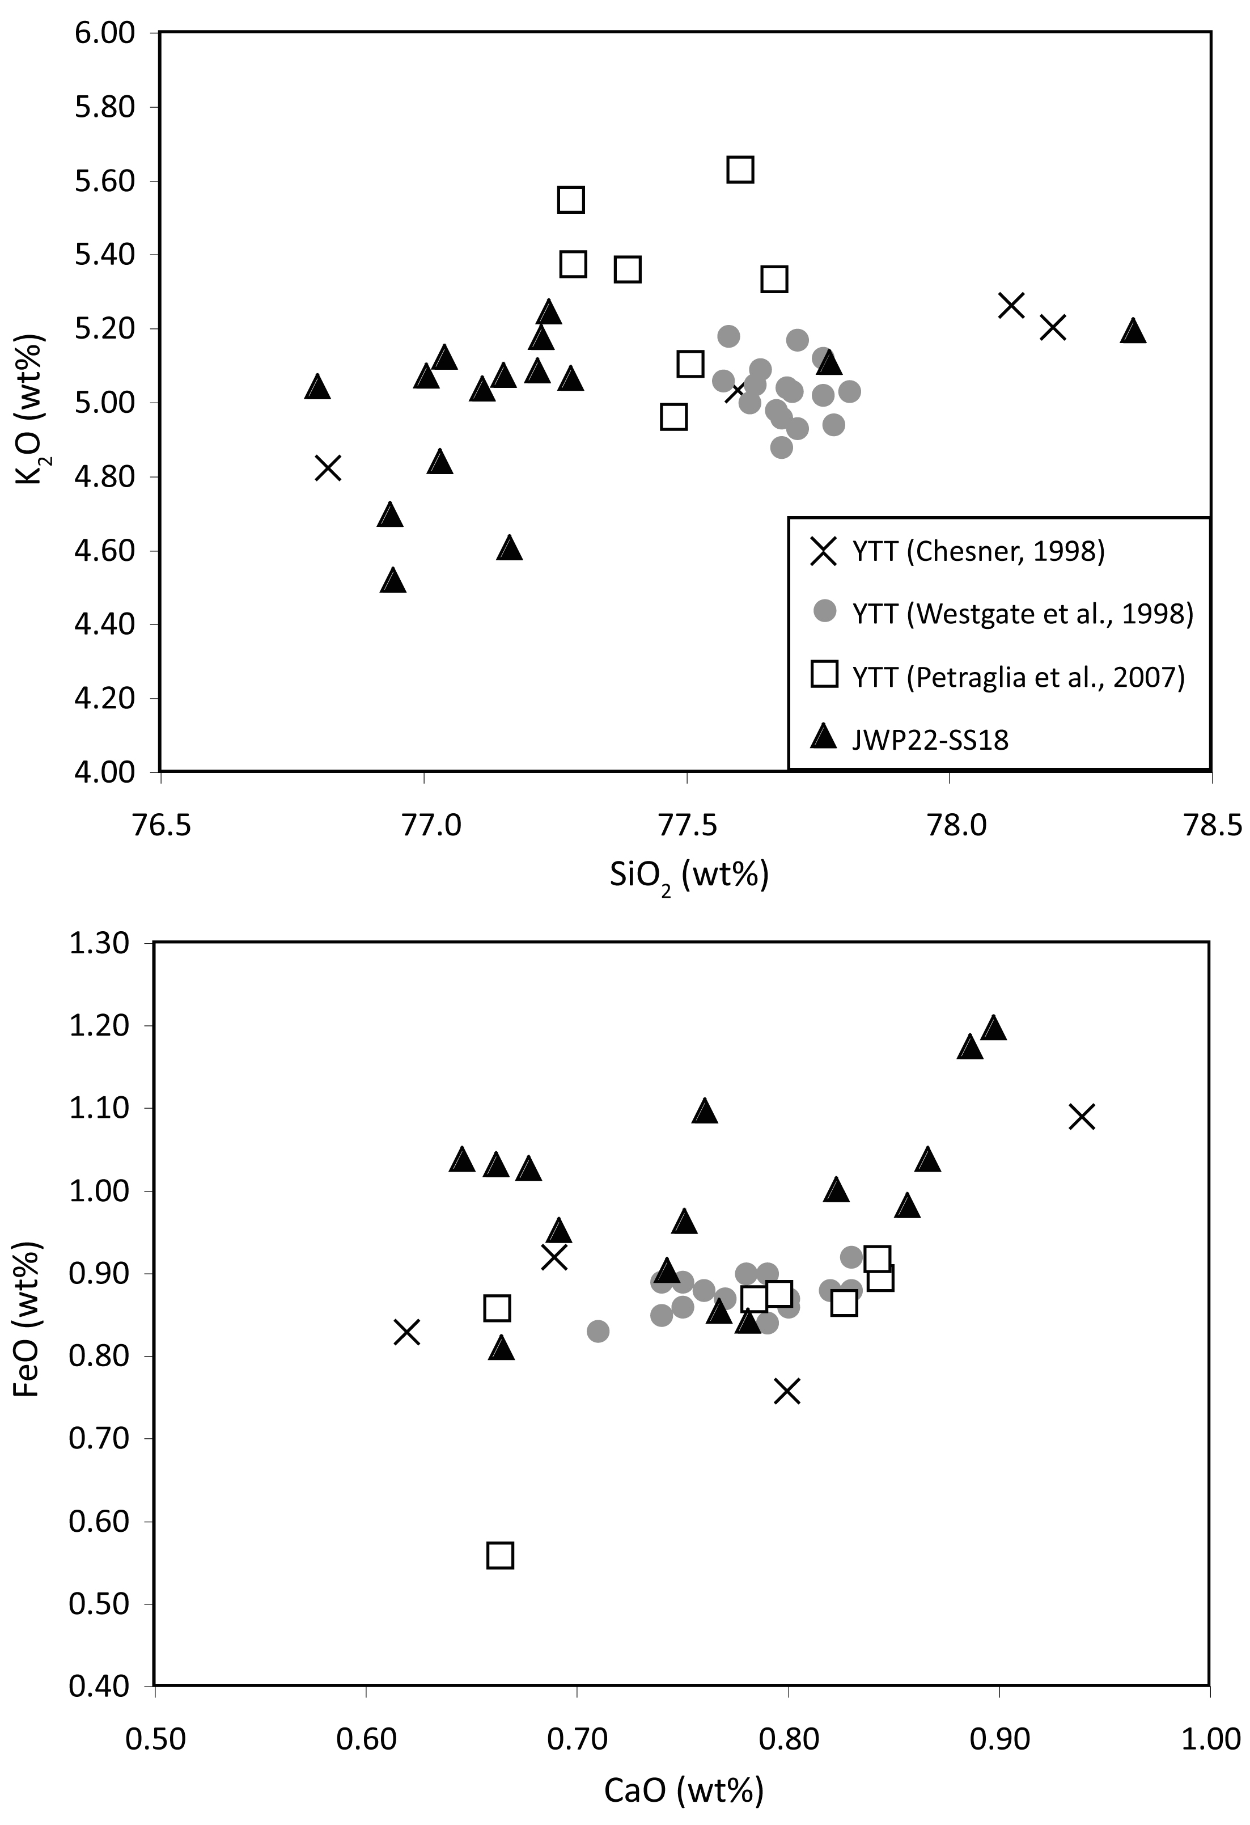

Fig. S1. Tephra glass shard chemical composition from Jwalapuram Locality 22 (JWP22-SS18), compared with published data on YTT Sumatran proximal deposits (Chesner, 1998) and other YTT findspots in India (Petraglia et al., 2007; Westgate et al., 1998)

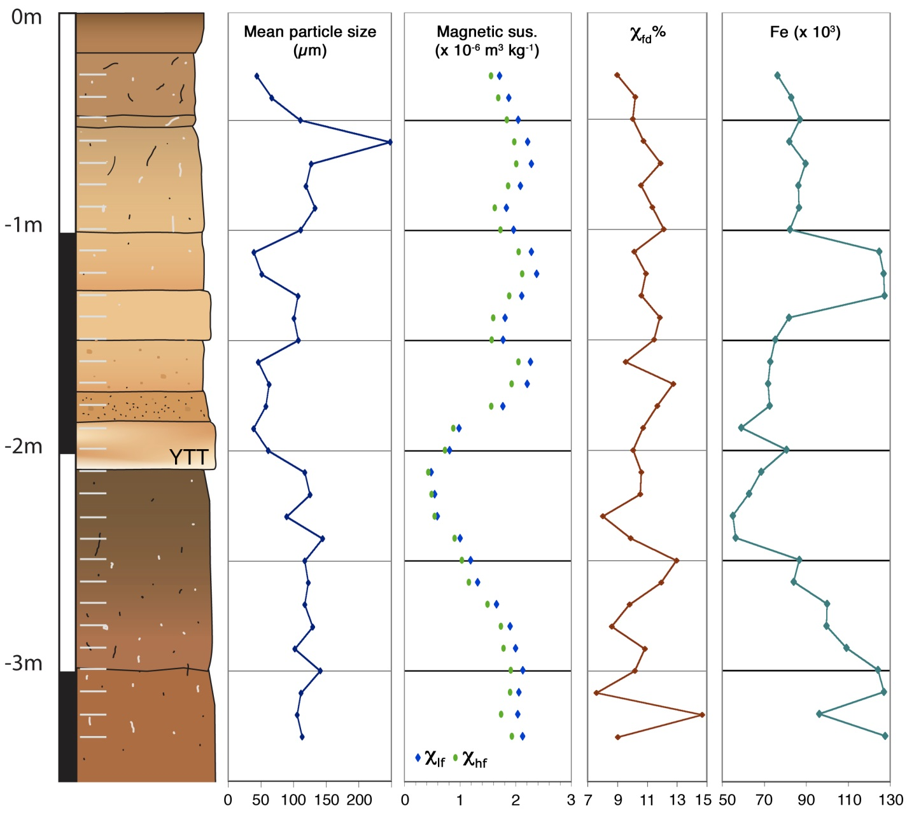

Fig. S2. Mean particle size, mass specific magnetic susceptibility (low [χlf] and high [χhf] frequencies), percentage frequency dependent susceptibility (κfd%), and iron (Fe) XRF values, Jwalapuram Locality 22. The sediment log shows the position of YTT deposits, and samples collected at 10 cm intervals from 30-330 cm depth

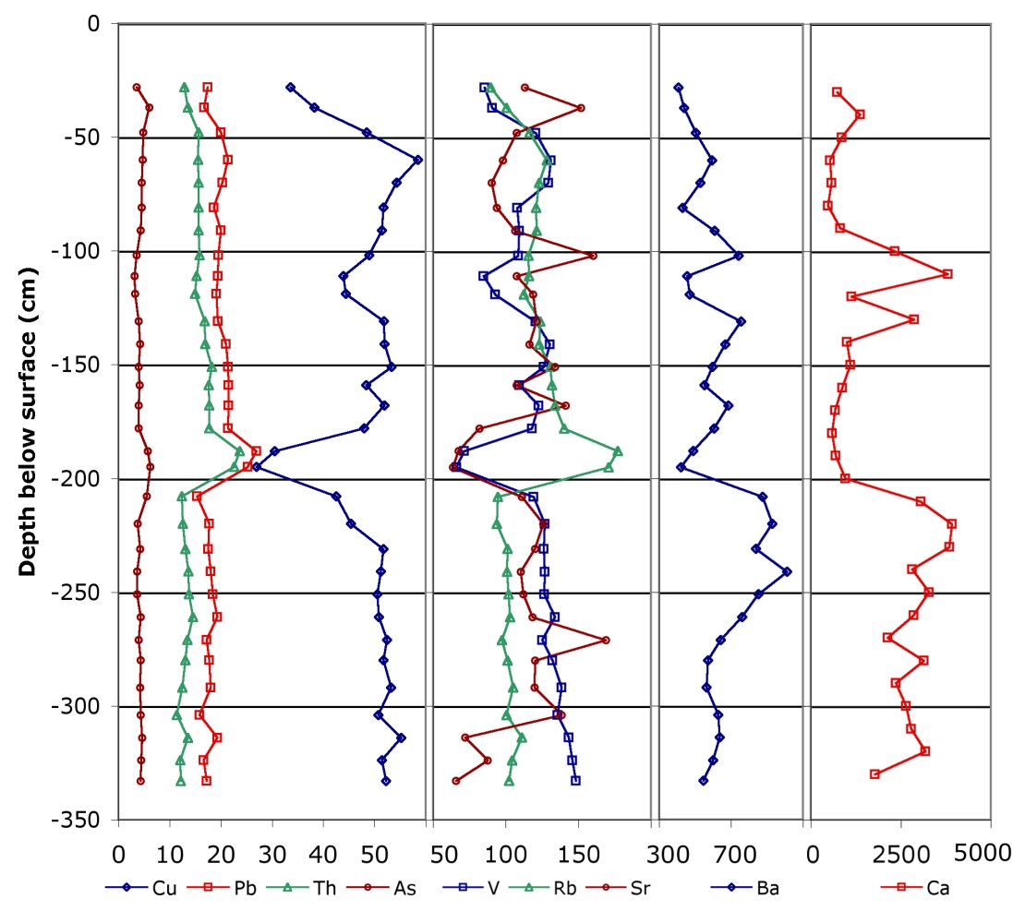

Fig. S3. XRF trace element results, 30-330 cm depth, Jwalapuram Locality 22. Note that each of the four charts has a separate scale. The Toba tephra is clearly identified as a discrete event separating the underlying occupation surface from overlying sediments



Fig. S4. Percentage of phytolith morphotypes from the Jwalapuram Locality 22 paleosol, underlying the Toba tephra, 202-212 cm depth

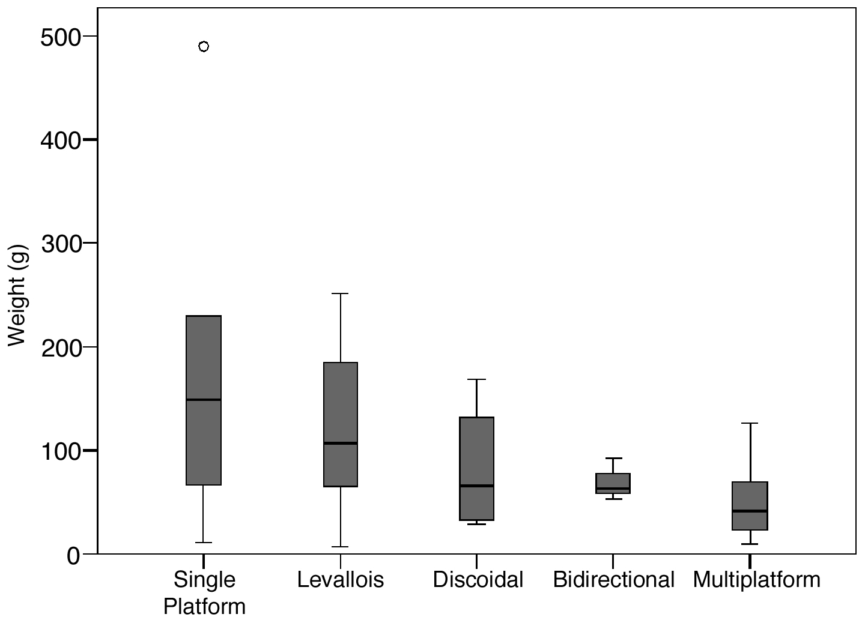

Fig. S5. Box plot of weight by core type, Jwalapuram Locality 22

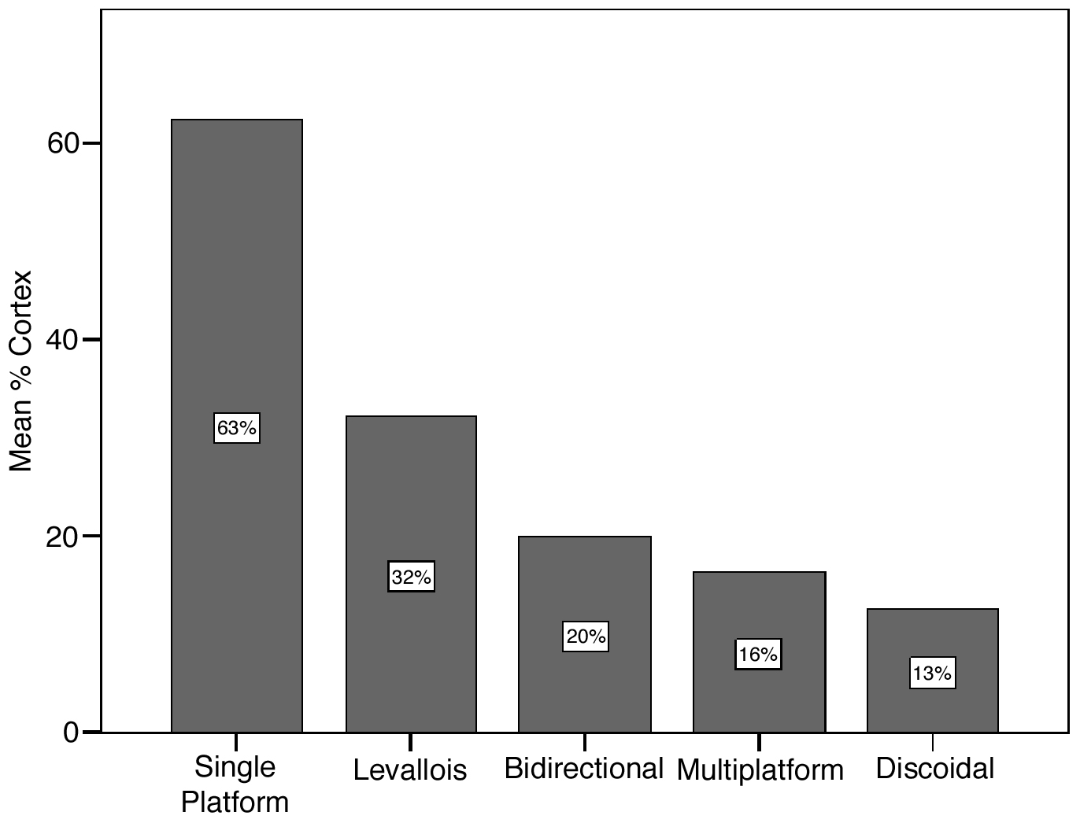

Fig. S6. Mean proportion of cortex (measured in 10% intervals) on each core type, Jwalapuram Locality 22

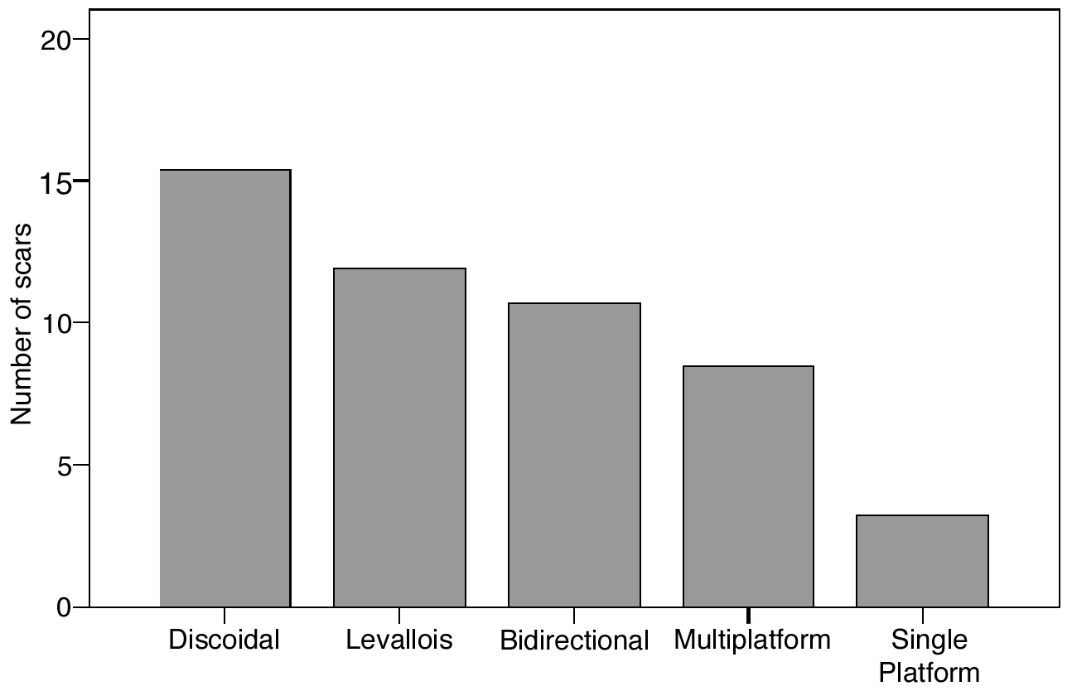

Fig. S7. Numbers of scars found on each core type, Jwalapuram Locality 22